Statement on behalf of the Expressway Action Group to the Growth Board.

My name is Peter Rutt and I am co-ordinator of the Expressway Action Group. Our members currently include 14 Parish councils of the Baldons, Cuddesdon & Denton, Garsington, Great Haseley, Horspath, Little Milton, Newington, Radley, Stadhampton, Tiddington, Warborough, Waterperry, Waterstock, and Wheatley.
The group was established when we discovered that the National Infrastructure Commission, Highways England and local Councils had been collaborating for months on plans for a new ‘Expressway’ motorway through the Oxford Green Belt. The proposals incorporate provision for up to 100,000 new homes in Oxfordshire. (source: NIC 2016 – document here)
The National Infrastructure Commission documents show that some of the Expressway route options would run for over 10 miles through protected Green Belt land, cutting key wildlife corridors and damaging the Thame flood plain. I have the map here.

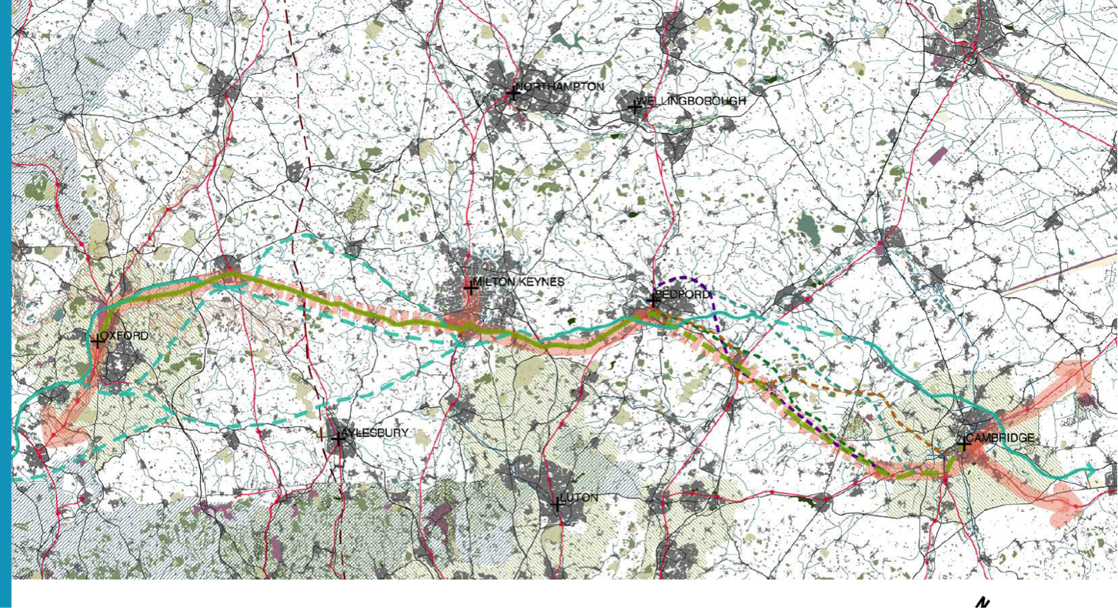 Source: NIC Expressway Competition publication 30th June 2017
- We understand that some Councillors and officials have been promoting a Southward route for the Expressway, which would leave the A34 near Abingdon and run through the protected Oxford Green Belt.
- It is difficult to understand the logic of this when there is a viable, cheaper and quicker option to the North along the existing dual-carriageway A34.
- Having read the NIC’s own reports and figures, it is clear that the ‘Southern Route’ has the following major disadvantages :
  - It costs £400 million more (see NIC Stage 3 Report p 47 *)
  - It would separate the new Expressway from the Rail corridor and the new stations at Oxford Parkway and Bicester,
  - It would run along the southern edge of the Growth Corridor rather than down its centre:
  - Most important, it would ruin 10 miles of Oxford Green Belt, causing massive damage to rural lands and wildlife. It would change the character of the area for ever.
  - There cannot be any business case which would outweigh the magnitude of the damage it would cause
- Growth Board minutes show that the Growth Board and its Councils have been collaborating with the NIC for months on detailed ‘workstreams’ to facilitate these plans And yet..
- At no time have our County or District Councils consulted with our member Parish Councils. All Freedom of Information requests to the NIC and Highways England have been refused.
- A full and open public discussion on ALL the route options should have been undertaken months ago before any recommendations are made.
- We are fearful that at the end of all this secret work we will be presented with a ‘fait accompli’ and only a single route option, on a ‘take it or leave it’ basis. This could be catastrophic for the environment and amenity of this Green Belt area.
The resulting public outcry would inevitably give rise to a full legal challenge: it is bound to result in full disclosure of all documents and discussions
- We therefore ask that the Growth Board and its member Councils :
  - engage with the Parish Councils and the wider public immediately and effectively; and
  - encourage the National Infrastructure Commission and Highways England to do the same.
- We cannot envisage any circumstances in which forecast economic growth could outweigh the certain environmental harm an Expressway and associated development through the Green Belt would cause, especially when there is a clear alternative.
I will of course provide the Growth Board with written copies of this statement for their Minutes.
// PLR 26 Sept 2017

References:
*Item 2 / NIC Stage 3 Report: table of costings for Expressway options – see p47 :
https://www.gov.uk/government/uploads/system/uploads/attachment_data/file/571353/oxford-to-cambridge-expressway-strategic-study-stage-3-report.pdf

